**Problem Statement:**

Consumer sleep mode for particular time

**Features:**

* Consumer should continuously copy a message from one topic to another topic.
* For particular time interval ( 9am to 4pm) consumer should be in sleep/pause state (ensuring connection is still there but message forwarding is not done).
* Other than this time interval the consumer should continuously forward messages one at time from source topic to destination topic.
* When consumer resumes (after time interval overs) then it should start forwarding messages from where it has left earlier (No duplicate or loss of messages).

**Package Installations: (in VS Code terminal)**

dotnet add package Confluent.Kafka

Note: Download kafka locally.

**Commands to Start the Application:**

**1st Terminal:**

cd C:\Users\maher\Downloads\kafka\

bin\windows\zookeeper-server-start.bat config\zookeeper.properties

**2nd Terminal:**

cd C:\Users\maher\Downloads\kafka\

$env:KAFKA_HEAP_OPTS="-Xmx1G -Xms1G"

.\bin\windows\kafka-server-start.bat .\config\server.properties

**3rd Terminal:**

cd C:\Users\maher\Downloads\kafka\

.\bin\windows\kafka-topics.bat --list --bootstrap-server localhost:9092

**To create Topics (eg. topic1 & topic2 ):**

.\bin\windows\kafka-topics.bat --create --topic topic1 --bootstrap-server localhost:9092

.\bin\windows\kafka-topics.bat --create --topic topic2 --bootstrap-server localhost:9092

**To start the Producer:**

.\bin\windows\kafka-console-producer.bat --topic topic1 --bootstrap-server localhost:9092

**4th Terminal:**

cd C:\Users\maher\Downloads\kafka\

.\bin\windows\kafka-console-consumer.bat --topic topic1 --from-beginning --bootstrap-server localhost:9092

**5th Terminal:**

cd C:\Users\maher\Downloads\kafka\

.\bin\windows\kafka-console-consumer.bat --topic topic2 --from-beginning --bootstrap-server localhost:9092

**Flow Diagram:**

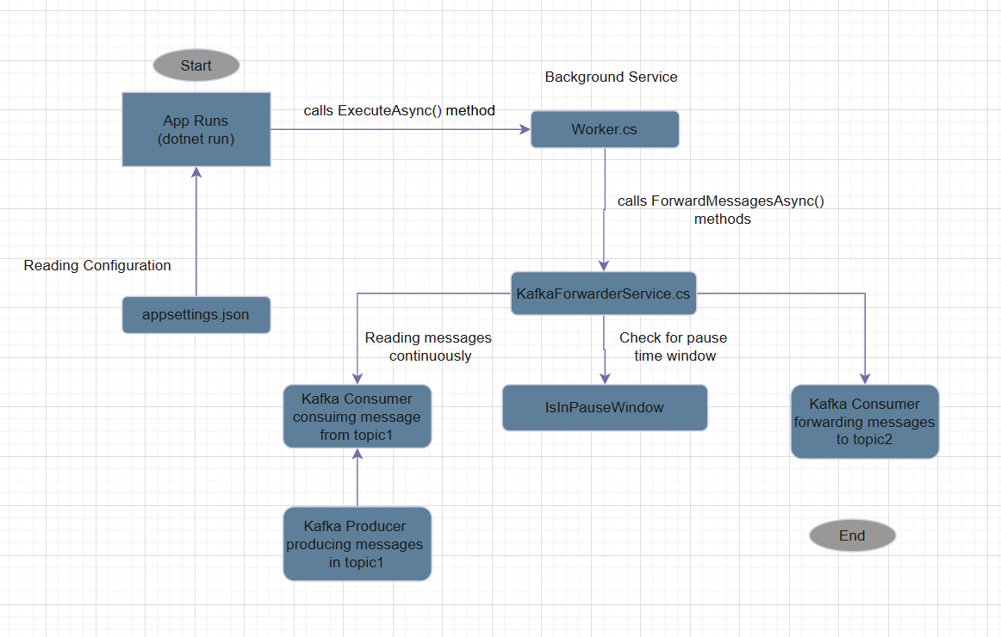

Flow Diagram